NATIONAL CENTER FOR SCIENTIFIC RESEARCH “DEMOKRITOS”


Institute of Informatics & Telecommunications

User’s Guide for PServer
Table of Contents
1) Introduction 3
1.1) What is PServer? 3
1.2) PServer Architecture 3
1.2.1) Logical Level 3
1.2.2) Physical Level 4
1.3) Benefits from using PServer 5
2) PServer’s Components & Explanation 6
3) Database Schema 7
4) Configuration & Running 16
4.1) Necessary Tools before Installation 16
4.2) Configuration 17
4.2.1) MySQL Configuration 17
4.2.2) Basic PServer Configuration 18
4.3) Using the Administration Panel 21
4.3.1) Logging in 21
4.3.2) Creating Pserver Clients 22
5) Make PServer requests 23
6) Using a web browser to enter data into PServer 25
6.1) Attributes and Features 26
6.1.1) Inserting Attributes 26
6.1.2) Inserting Features 26
6.2) Stereotypes 27
6.3) Communities 28
6.4) Feature Groups 28
6.5) Deleting a PServer client 29
7) Implement a PServlet 30
8) FAQ 32
8.1) Questions and Answers 32
8.2) Troubleshooting 32
9) About Models - Detailed 32
9.1) A PersonalMode 32
9.2) B StereotypeMode 34
9.3) C Community Mode 35
9.4) D CVS Mode 35

Introduction

What is PServer?

PServer is an application that is developed from the National Center of Scientific Research “Demokritos” of Greece and is a general purpose personalization server. So PServer is a program with functionality that can be used by different kind of applications that need to provide personalized facilities.
PServer is designed to be platform and application independent, that means it can run on different operating systems and can provide generic personalization services to application that the content is unknown. To accomplish these tasks PServer's implementation has been done with the programming language Java and without any usage of operating system API and is usable under any known operating system that has a port of Java virtual machine version 1.5+.
We have tested PServer under Linux, Windows and Solaris and works perfectly. PServer needs a RDBMS to store its data and we have chosen MySQL (version 5+) which is a very mature , open source and has a version for all the known operating systems software. Furthermore to be platform independent PServer is designed to communicate over HTTP protocol. Applications can make simple HTTP requests that contains the parameters of the request and gather results through XML documents. This is pretty much the same way that RESTful web services works but it is even “lighter”.

PServer Architecture

Logical Level
PServer’s central point is the user’s modelling, where three different models are provided. Specifically, Pserver can create and update user models (one for each user of a specific application), stereotype models and also community models.
Personal user models: They are regarded as information that are stored for each user. For example, they could be exhibits that the user has visited or how many times have seen each exhibit. Users are determined by their specific attributes and characteristics. Attributes are regarded to the personal information of the user where they remain unchanged during his interaction with the system (ex. the language where he receives the information, the age and so). Features are referred to ontology of the specific application and they have arithmetic values where they manifest the importance for the specific user. For example, one «micro-plan» can be suitable for adults and unsuitable for young children. So, the relative features will have a high value for adults and a low for children.
Stereotypes: They are groups of users with common attributes. For example, adults or children. Stereotypes have attributes and features like user models, but they have a basic difference. It’s not necessary for each stereotype to have the same number of features and attributes with the rest of others.
User Communities: It is possible for PServer, with the use of machine learning algorithms, to create groups of users and groups of features based on users’ interact with the system. Users’ groups are created through the finding of similarities between users, with the use of clustering algorithms. For the groups of features, we would like to learn which have approximately the same values for users. For example, if a feature is so important with another for many users, we have to know it, because if a new user wants something, then something else can be proposed to him, which the user will possibly be interested in.
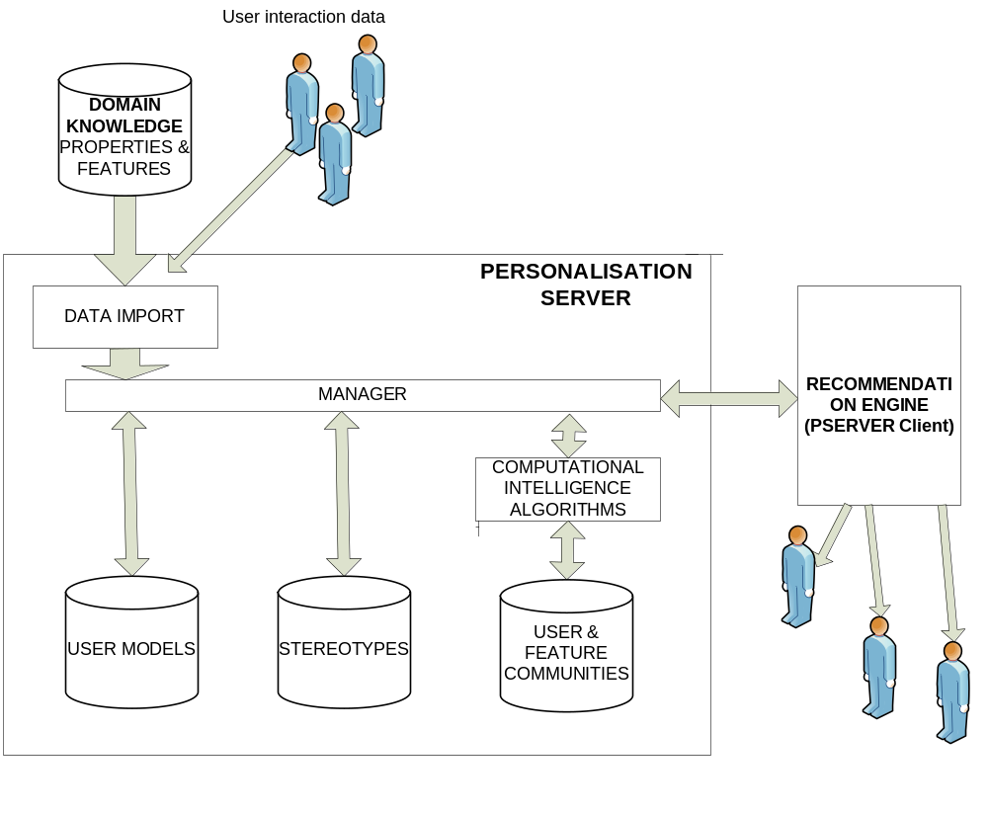

Physical Level
In physical level, PServer may reside at a different machine as the application and is implemented as a Web server that listens to a dedicated port, where all requests have the form of HTTP messages. Web browsers can be used as PServer clients and responses from Pserver are encoded in XML syntax, and especially made XSL style sheets allow them to be displayed on browsers. Also, to facilitate applications, a client-side library of classes is available that can be incorporated into the application to handle all low-level communication details.

Benefits from using PServer
- Personalization functionality as a web service:
  - Centrally installed and maintained.
  - Completely separated from applications.
  - Possible for many applications to use concurrently.
  - Easily accessible through HTTP.
- Towards an adaptable model.
  - central concepts: application features, users.
  - Feature semantics not part of PServer.
  - Features organization in a graph-like manner facilitates querying.

PServer’s Components & Explanation
The main component of PServer is its data model because with that we have an abstract way to express users, likes, interests and apply (data mining) algorithms to extract information that can be useful to different kinds of applications. This model makes PServer application independent because we do not store any application semantics and we express different content types with generic types. The generic types that we use are the following.
User: is the entity that we want to stores his/hers interests and likes
Feature: is any object that we want to express how much the user likes or he/she is interesting about. A user can express his like and interesting about a feature. We make this distinction because a user might be interesting about features that does not likes at all
Attribute: is any physical characteristic that a user has, for example age is a user attribute
User stereotype: is a group of users that have some common attributes. We use it for collaborating filtering. A user stereotype has users that belong to it and its profile is calculated by a mathematical formula (sum etc) that takes input the user profiles that are part of the stereotype.
User communities: is a group of users that has common likes about features.
Feature group: is a group of features that many users like concurrently
PServer applications can define correlation between PServer objects like between features to create (user based) graphs where spreading activation algorithms can be used to infer implicit knowledge about profiles that we do not have explicit information.

Database Schema
Bellow we describe the database tables of PServer's database. In every table there is an extra field that we do not comment at every table because it has the same meaning. This field is FK_psclient varchar(50) and is used to determine the PServer client that uses this data. We wanted PServer to be accessible by many different applications simultaneously and we had the need to define this field.
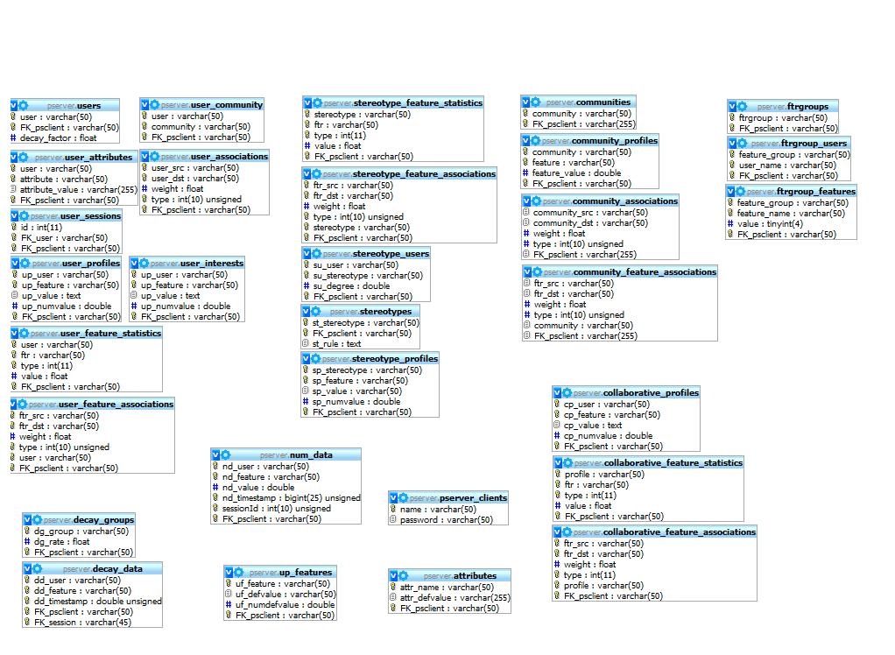
User Related Tables
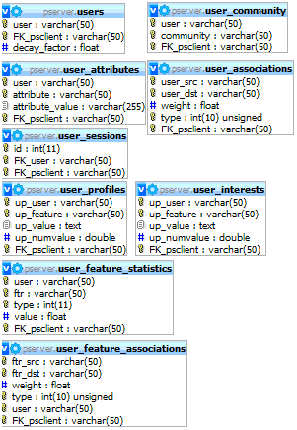

Stereotype Related Tables
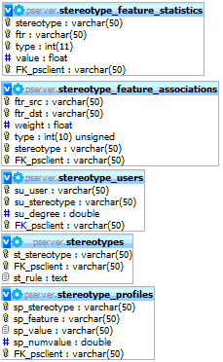
Communities Related Tables
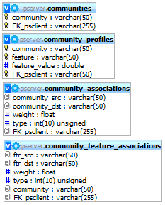

Feature Groups Related Tables
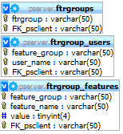

Decay Related Tables
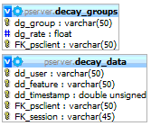

Numeric Data Table
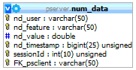

User Profile Features Table
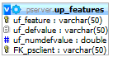

PServer Clients Table
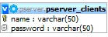

Collaborative Related Tables
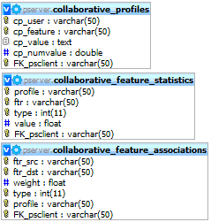

Attributes Table
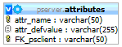

Tables Description
attributes: This table contains the user attributes
attr_name → The name of a attribute.
attr_defvalue → The default value of the attribute.
FK_psclient

collaborative_profiles:
cp_user
cp_feature
cp_value
cp_numvalue
FK_psclient
(Not yet used in code this table)

collaborative_feature_statistics:
profile
ftr
type
value
FK_psclient
(Not yet used in code this table)

collaborative_feature_associations:
ftr_src
ftr_dst
weight
type
profile
FK_psclient
(Not yet used in code this table)

communities: This table contains the user communities
community → The name of the community
FK_psclient

community_associations: This table contains the correlations between user communities
community_src
community_dst
weight
type
FK_psclient
(Not yet used in code this table)

community_feature_associations: This table contains the correlations between features of the user communities
ftr_src
ftr_dst
weight
type
community
FK_psclient
(Not yet used in code this table)

community_profiles: This table contains the likes of a community
community → The name of the community
feature → The feature name that belongs to this community
feauture_value → The value for this feature
FK_psclient

decay_data: This table contains logs about feature usage
dd_user → The name of the user related the decay data
dd_feature → The feature name for current decay data
dd_timestamp → The time between 2 decay data update times
FK_psclient
FK_session → The name of the session for this user

decay_groups: This table contains groups of decay data. There is explanation about these data at PServer's command manual that can be accessed through html pages from PServer.
Dg_group →
Dg_rate →
FK_psclient

num_data: This table contains logs of feature like values
nd_user → The user name of the numeric data.
Nd_feature → The feature name for the current numeric data.
Nd_value → The value for the numeric data of current feature.
Nd_timestamp → The time since last update for current feature.

ftrgroups: This table contains the feature groups.
Ftrgroup → The name of a feature group.
FK_psclient

ftrgroup_users:
feature_group → The name of a group.
User_name →The name of a user.
FK_psclient

ftrgroup_features: This table contains the profile of feature groups. This is a binary array that defines the features that belongs to feature group and the features that don't.
feature_group →The name of the group.
feature_name → The name of the feature that belongs to current group.
value → The value for this feature.
FK_psclient

pserver_clients: This table contains the applications that are registered to use the PServer.
Name → The name of a client.
Password → The password that is needed for this client.

Stereotypes: This table contains the stereotypes that are needed by an application.
St_stereotype → The name of a stereotype.
FK_psclient
St_rule →

stereotype_attributes: This table contains the attribute values that the stereotype consists of.
Sp_stereotype → The name of the stereotype.
Sp_attribute → The name of the attribute for current stereotype.
Sp_value → The value of the attribute.
FK_psclient

stereotype_profiles: This table contains the likes of Stereotypes.
Sp_stereotype → The name of the stereotype.
Sp_feature → The name of the feature that belongs to the stereotype.
Sp_value → The value of the feature
Sp_numvalue → The numeric value of the feature.
FK_psclient

stereotype_feature_associations: This table contains the correlations of Stereotypes.
Ftr_src → The name of the feature.
Ftr_dst → The distance that is calculated between other features belonging to this stereotype.
Weight → The weight for this feature.
Type →
Stereotype → The stereotype in which the feature belongs.
FK_psclient

stereotype_feature_statistics:
stereotype → The name of a stereotype.
ftr → The name of the current feature.
Type →
Value → The value of this statistic.
FK_psclient
(Not yet used in code this table)

stereotype_users: This table contains the users that belongs to a stereotype.
Su_user → The name of a user that belongs to a stereotype.
Su_stereotype → The name of the stereotype.
Su_degree →
FK_psclient

up_features: This table contains the features that are defined by the applications.
Uf_feature → The name of a feature.
Uf_Defvalue → The default value that will be used during creation of a stereotype feature or user feature.
Uf_numdefvalue → The default numeric value that is used in creation of a feature.
FK_psclient

user_associations: This table contains the correlations of the users.
User_sec → The name of a feature.
User_dst → The distance that is calculated between other features belonging to this user.
Weight → The weight for this feature.
Type →
FK_psclient

user_attributes: This table contains the values of user attributes.
User → The name of a user.
Attribute → The name of a attribute for a user.
Attribute_value → The value of a attribute.
FK_psclient

user_community: This table contains the communities that users belong to.
User → The name of a user.
Community → The name of a community.
FK_psclient

user_feature_associations: This table contains the correlations of features for a user. If we want to describe correlations in general that is not personalized we leave the user field of this table with the empty string.
Ftr_src → The name of a feature.
Ftr_dst → The distance that is calculated between other features belonging to this user.
Weight → The weight for this feature.
Type →
User → The name of a user.
FK_psclient

user_feature_statistics:
user → The name of a user
ftr → The name of a feature which statistics are calculated.
Type →
Value → The value of this statistic item.
FK_psclient
(Not yet used in code this table)

user_profiles: This table contains the likes of the users.
Up_user → The name of a user.
Up_feature → The name of a feature that belongs to a user.
Up_value → The value for this feature.
Up_numvalue → The numeric value for this feature.
FK_psclient

user_interests: This table contains the interests of the users.
Up_user → The name of a user.
Up_feature → The name of a feature.
Up_value → The value of this feature.
Up_numvalue → The numeric value of this feature.
FK_psclient
(Not yet used in code this table)

user_sessions: This table contains the ids of the sessions that exist in tables decay_data and num_data.
Id → The id of a session.
FK_user → The name of a user with this session.
FK_psclient

users: This table contains the users.
User → The name of a user.
FK_psclient
Decay_factor →

Configuration & Running

Necessary Tools before Installation
As we have said PServer is implemented in Java and uses MySQL as its RDBMS. That means that if you want to install PServer first you must have to install MySQL version 5+, it is also advisable to install the MySQL Admin Tools, that provide a GUI, and JVM version 1.5+. You can download these applications from the sites of MySQL and Sun for free. After the installation you must create a database for PServer and import the PServer's database script into MySql to construct the database.

- PServer
- MySQL (it’s also good idea to install administration tools, or another visual environment)
- Java runtime edition (JRE) and preferably a java compiler (JDK) as well as a development environment (Netbeans)

Configuration

MySQL Configuration
#First, you have to start MySQL and import the database schema. Then, you have to create a user (pserver), and assign full privileges to this user. To do this, open command prompt and type the following:
cd <path to mysql/bin folder>
Ex: C:\xampp\mysql\bin

mysql –u root –p

#To import now the database schema from file pserver_db.sql that comes with PServer files, type the following:
\. <replace this with the correct path of db file>\pserver_db.sql
Ex: \. C:\pes\sql_dump\pserver_db.sql
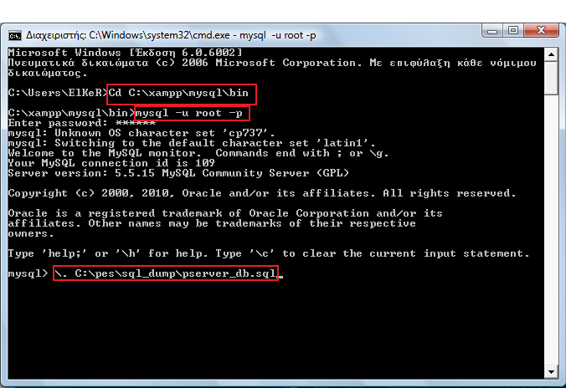

#To add new user for MySQL with full privileges to the database you created previously, type:
GRANT ALL PRIVILEGES ON <DB_NAME>.* TO 'my_user'@'localhost' IDENTIFIED BY 'my_password' WITH GRANT OPTION;
Ex: GRANT ALL PRIVILEGES ON pserver.* TO 'pserver'@'localhost' IDENTIFIED BY 'ff0123' WITH GRANT OPTION;
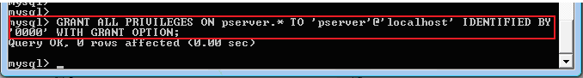

Basic PServer Configuration
You have to set up variables in server.ini and pbeans.ini files that exist in folder \Pserver, as follows.

In server.ini:
You provide the user/name and password
Database_pass=0000 (no quotes, with password that you entered previously)
database_user=pserver ( no quotes, the user that you created)
database_url= mysql\://127.0.0.1/pserver (or the host of your mysql)

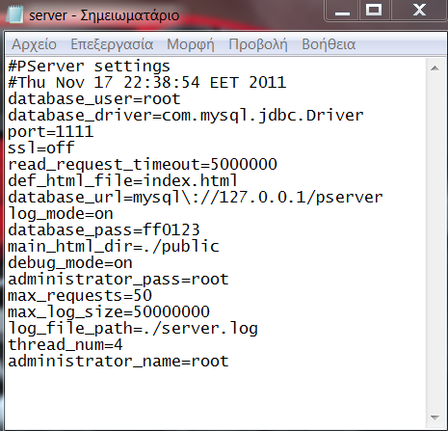

Server.ini Variables Explanation

database_user=pserver
This parameter defines the user that is used by the PServer to connect to database

database_driver=com.mysql.jdbc.Driver
This parameters defines the jdbc driver that will be used to connect to database.

port=1111
This is the TCP port that PServer will bind to listen for requests.

ssl=off
This parameters defines if the communication will be done by secure shell mode.

read_request_timeout=5000
This parameters defines the maximum time in milliseconds that PServer will keep a connection open waiting for a request

main_html_dir=./public
Pserver is a simple HTTP server and can serve files. This parameter defines the directory that contains

administrator_name=root
This parameter defines the username for administrator user

administrator_pass=root
This parameter defines the password of the administrator user.

def_html_file=index.html
This parameter contains the default name of the HTML file that PServer serves from its web content directory.

database_url=mysql\://127.0.0.1/pserver
This parameter defines the jdbc URL that is used to connect to database

log_mode=on
This parameter defines if it will be stored a log into a file

database_pass=0000
This parameter defines the password for RDBMS user that is used to connect to database

debug_mode=on
This parameter defines if we want to log extra debug messages from the PServer

max_requests=50
This parameter defines the maximum requests that can be accepted concurrently.

max_log_size=50000000
This parameter defines the maximum log file size in bytes

log_file_path=./server.log
This parameter defines the file that log will be stored

thread_num=5
This parameter defines the maximum threads that can use PServer to execute processing. PServer might has to process a great amount of data and this takes time. We use threads for parallel processing to to speed up the server responses. These days every CPU has more than one cores and you have to parameterizde PServer to use these cores. For an Intel Core 2 duo our experiments has shown that the performance is increased until 4 threads and for a Intel Core 2 quad until 5 threads. An I7 CPU has greater scaling but we do not have determine its limit yet.

In pbeans.ini:
admin=pserver.pservlets.Admin (admin,admin name,admin pass)
Replace admin name and admin pass with the values that you want to use when you log in to the administration panel of Pserver. The word admin is a constant and should stay as it is.
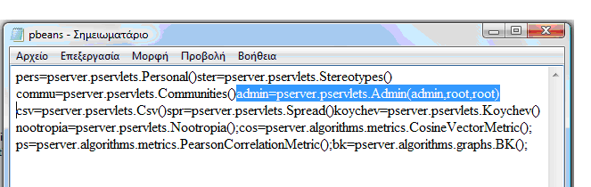

pbeans.ini variables explanation
This tells the PServer to load objects of different classes (pbeans) that pserver will put into hash maps and can share their functionality through Java reflection. We will explain how to write pbeans and use them later for now just remember that any plug-in that you want to insert and use must be defined in this file with a unique name. The definition is done by typing a name the operator of equality and a class name. The parenthesis after the class name defines the pbean initialization parameters. The preinstalled pbean admin contains the functionality for the administration interface of PServer that we have shown before. It takes three parameters first the name that is defined into pbeans.ini, the login name (the first root) and the login password that user must type to make a successful log in. When you want to use the administration tool you have to provide these two words to gain access. If you want to change these words just make the changes here, save the file and make a restart of the PServer.

Using the Administration Panel

Logging in
- Run PServer, (in windows run the pserver.bat) * HELP

- Open a browser and type http://localhost:1111

- You should see the PServer Administration Panel

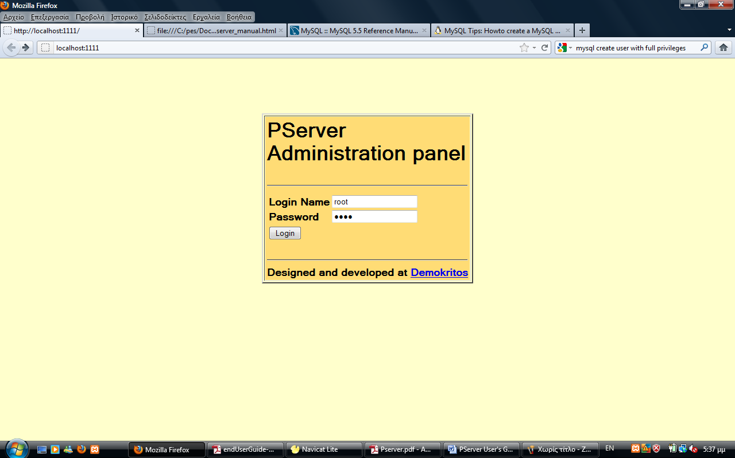

- Now log in with your username and password you set in pbeans.ini file

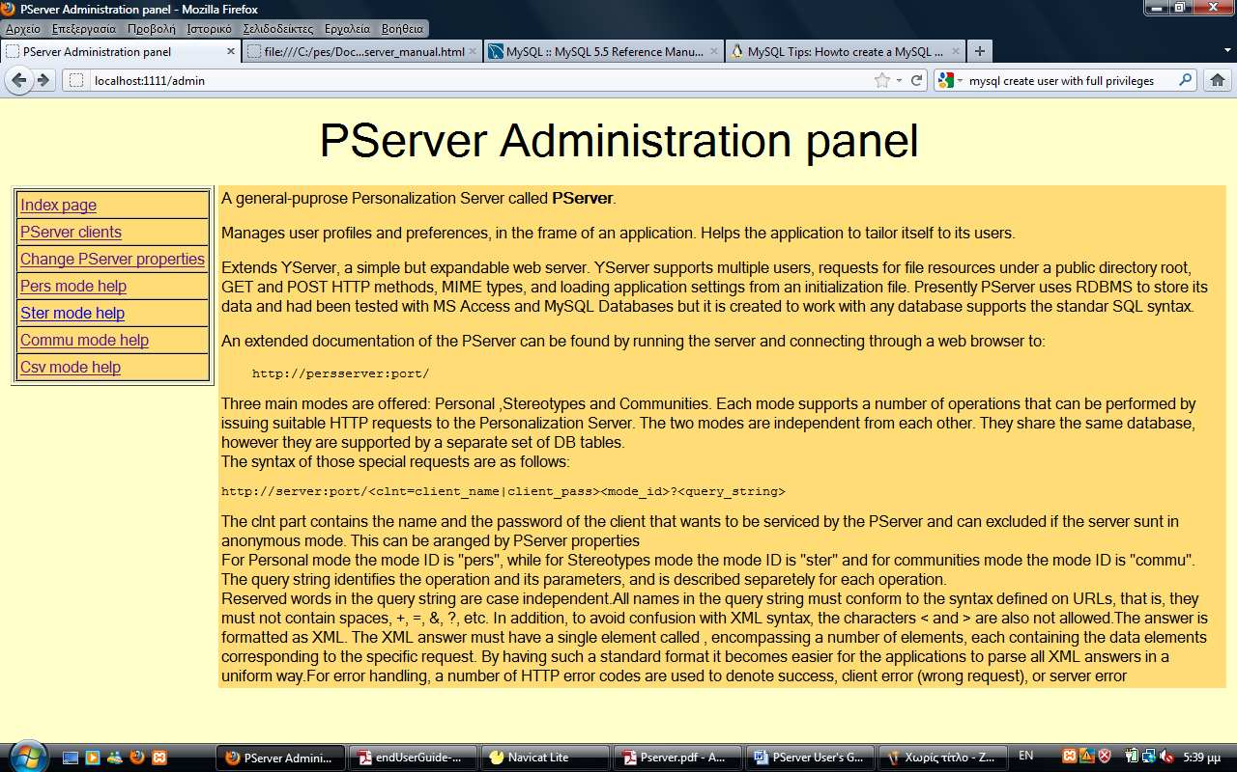

Creating Pserver Clients
- Go to «PServer clients» page and type in your client (application) username and client (application) password.
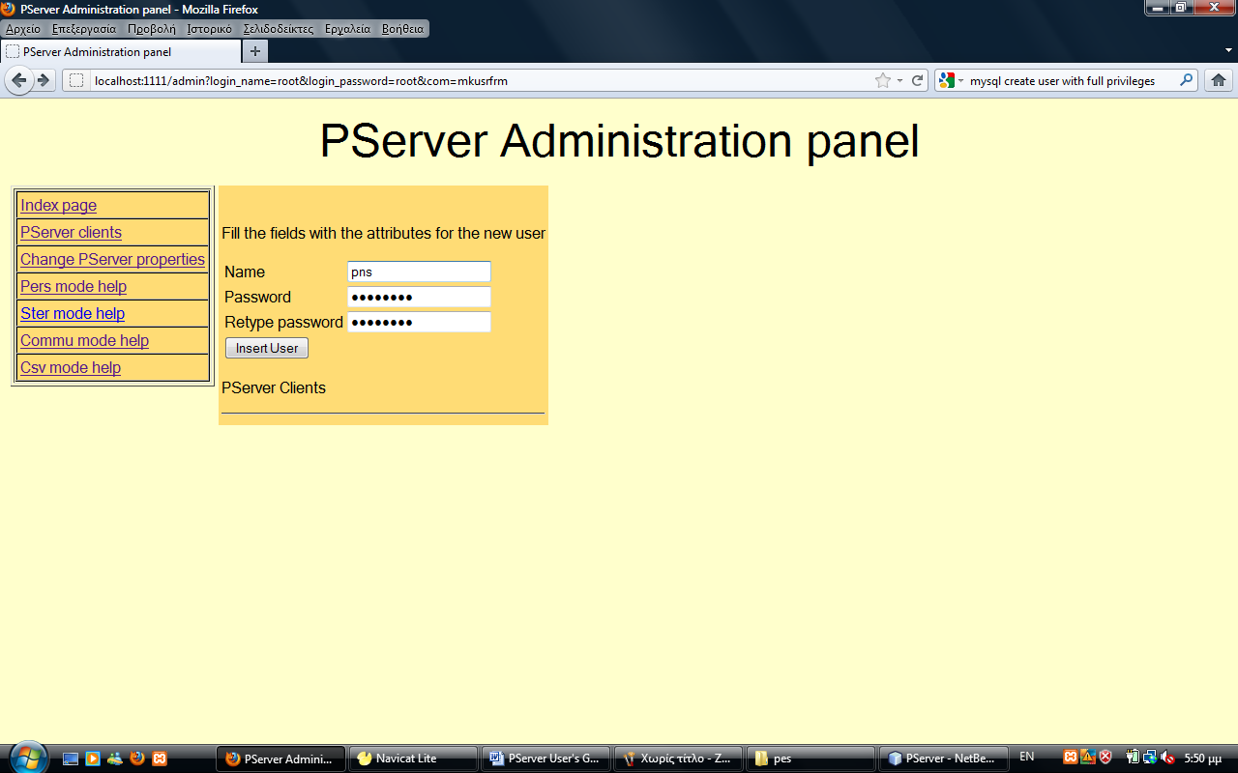

Make PServer requests

PServer is an HTTP application server that runs plug-ins (pservlet pbeans) that serves the requests and returns responses. Based on this logic the requests that you make to PServer has specific structure

http://url/<pbean_name>?clnt=name|pass&com=some_com&param1=val1&param2=val2...

First you define the URL that links to PServer, then the pservlet that you want to use and then the client name/pass that makes the request and the pservlet parameters. Every pservlet defines its own parameters. The pservlets that we have written has a common structure, they need to get a com parameter that defines the pserver command that needs to be called and then the parameters of the specified commands. pservlets can return any type of document (HTML,XML,JSON etc) but the ones that we have implemented and we use return XML. The admin pservlet is an exception, it returns HTML documents and this is needed to access it through a web browser. The XML that is returned is always structured like a 2d array. You can see the structure by reading the xsl files that we provide with PServer and exist in the resp_xsl folder inside the public folder. For example we are printing one of these:

<?xml version="1.0"?>
<xsl:stylesheet xmlns:xsl="http://www.w3.org/TR/WD-xsl">
<xsl:template match="/">
<html>
<head>
<title>View from Table: up_features</title>
</head>
<body>
<br></br>
<h2>features and default values</h2>
<p></p>
<b>Tables:</b> up_features
<br></br>
<b>Description:</b> A_selection_of_(feature,_default value)\-pairs.
<p></p>
<table border="1" cellpadding="4">
<xsl:for-each select="result/row">
<tr>
<th>
<xsl:value-of select="ftr"/>
</th>
<td>
<xsl:value-of select="defval"/>
</td>
</tr>
</xsl:for-each>
</table>
<br></br>
<a href="/">Back to home</a>
<p></p>
</body>
</html>
</xsl:template>

These xsl files are used to provide formated output to web browsers. Type commands into a web browser (like Firefox) and you will get results that sows the 2d arrays philosophy. For example, like the above.
Here is the XML document from the execution of a command:
http://127.0.0.1:1111/pers?clnt=test1|test1&com=getusrs&whr=*

<?xml version="1.0" encoding="UTF-8" ?>
<?xml-stylesheet type="text/xsl" href="/resp_xsl/user.xsl"?>
<result>
<row><usr>1</usr></row>
<row><usr>10</usr></row>
<row><usr>100</usr></row>
….
<row><usr>194</usr></row>
<row><usr>195</usr></row>
<row><usr>196</usr></row>
<row><usr>197</usr></row>
<row><usr>198</usr></row>
<row><usr>199</usr></row>
<row><usr>2</usr></row>
</result>

Inside the public folder of PServer there are subdirectories that contains help about every implemented pservlet and its API.

There is full documentation about the methods that PSClientRequest provides at the Java docs that are bundle with the Pserver.

Using a web browser to enter data into PServer
You have two ways to enter information into the P-server:
a) the web browser
b) through a program such as java.
In any case it is important to remember that you do not enter data directly into the database, but rather you must do it through a client application to the PServer. The client has an obscure and hard to change password.

http://localhost:1111/pers?clnt=testclient|testpass&com=addattr&job=1

'pers'=personal mode (i.e. not stereotypes, or communities. In other words individual users).
'testclient'=the client
'testpass'=password to the client
'\&' separator
'com=addattr' = command add addtibute
'job=1', the hypotherical attributr job assumes the value 1

Provided you have created the database schema with 'pserver.sql', you should be able to see the results in the 'attributes' and user 'attributes' tables.

Attributes and Features

Inserting Attributes

Add attributes:
pers?clnt=testclient|testpass&com=addattr&age=null&sex=null&occupation=null
This adds age, sex, occupation and their default values (null, null, null) as attributes in 'attributes' table.

Add attribute values along with user:
pers?clnt=testclient|testpass&com=setusr&usr=user1&attr_age=12&attr_sex=male&attr_occupation=journalist
This adds the user1 to table 'user' and the attributes in 'user attributes' table.

Remove attributes:
pers?clnt=testclient|testpass&com=remattr&attr=sex&attr=age
pers?clnt=testclient|testpass&com=remattr&attr=* (deletes all attributes and user attributes)

Inserting Features
Add features:
pers?clnt=testclient|testpass&com=addftr&movieID=0
This adds movieId and default value 0 as feature in ‘up_features table’.

Add feature values to a user:
pers?clnt=testclient|testpass&com=setusr&usr=user1&ftr_movieID=12
This adds to user1, the feature movieID with value 0 in table 'user_attributes'.

Remove features:
pers?clnt=testclient|testpass&com=remftr&ftr=&ftr=movieID
pers?clnt=testclient|testpass&com=remftr&ftr=* (deletes all up_features and user features)

Get default values for features and attributes:
pers?clnt=testclient|testpass&com=getattrdef&attr=*

Increase the value of a feature for a user:
pers?clnt=testclient|testpass&com=incval&usr=user1&movieID=1

Stereotypes

Creating Stereotypes:
ster?clnt=testclient|testpass&com=addstr&str=str18_25GR10male
(age:18-25, country: Greece. Occupation: 10, sex: male)

Adding users to a stereotype:
ster?clnt=testclient|testpass&com=addusr&usr=user1&str18_25GR10male=1
(add the user1 to stereotype str18_25GR10male with degree 1)

Increase the value of a feature for a stereotype:
ster?clnt=testclient|testpass&com=incval&str=str18_25GR10male=1

Remove a stereotype:
ster?clnt=testclient|testpass&com=remstr&str=str18_25GR10male

List all stereotypes:
ster?clnt=testclient|testpass&com=lststr&str=*
ster?clnt=testclient|testpass&com=lststr&str=str18_25GR10male

Communities
In order to create user communities, previously you have to create the user distances using one of the two metrics.

Using metric cos (Cosine Vector Metric)
commu?clnt=testclient|testpass&com=calcudist&smetric=cos

Using metric ps (Pearson Correlation Metric)
commu?clnt=testclient|testpass&com=calcudist&smetric=ps

The following will create communities with bk (BronKerbosch) algorithm and a given threshold (>0.5). Threshold values can be set from 0 to 1.
commu?clnt=testclient|testpass&com=mkcom&algorithm=bk&th= >0.5

Feature Groups
In order to create feature groups, previously you have to create the feature distances using one of the two metrics.

Using metric cos (Cosine Vector Metric)
commu?clnt=testclient|testpass&com= calcftrdist&smetric=cos

Using metric ps (Pearson Correlation Metric)
commu?clnt=testclient|testpass&com= calcftrdist&smetric=ps

The following will create communities with bk (BronKerbosch) algorithm and a given threshold (>0.3). Threshold values can be set from 0 to 1.
commu?clnt=testclient|testpass&com=mkftrgrp&algorithm=bk&th=>0.3

Deleting a PServer client
To delete a client such as the testclient along with the relevant data, you must perform the following:
- Run Pserver, (in windows run the pserver.bat)
- Login in http://localhost:1111
- You should see the PServer Administration Panel
- Go to PServer clients.
- Click on the Delete next to the client you are interested in.
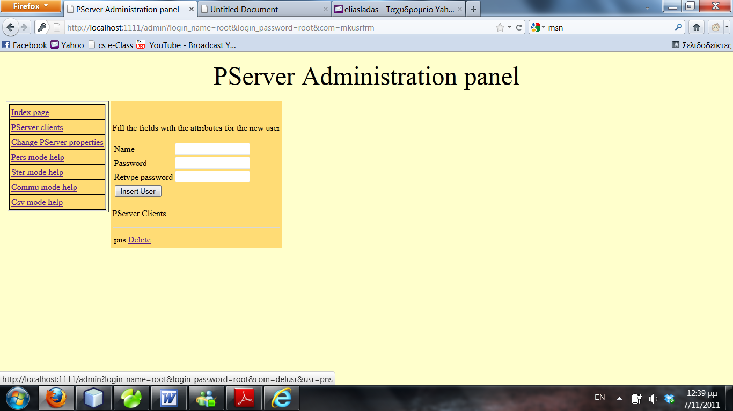

Implement a PServlet

To implement your own pservlet you must create a Java class implement the pserver.pservlets.PService interface. This interface has the following methods.

public abstract String getMimeType();
This method returs the MIME type of the document that your pservlet returns. For example text/xml if you want to return XML documents.

public abstract void init( String[] params ) throws Exception;
This method will be called when the PServlet will be loaded

public abstract int service( VectorMap parameters, StringBuffer response, DBAccess dbAccess );
The method contains the functionality that pservlet provide. It gets the request parameters into a VevtorMap, the response object will contain the returned document after the execution of the pservlet and dbAccess is an object that provides access to PServer database.

A typical pservlet implementation will looks like this.

public class SomeServlet implements pserver.pservlets.PService {
public void init( String[] params ) throws Exception {
}

public String getMimeType() {
return pserver.pservlets.PService.xml;
}

public int service( VectorMap parameters, StringBuffer response, DBAccess dbAccess ) {
int respCode;
VectorMap queryParam;
StringBuffer respBody;

respBody = new StringBuffer();
queryParam = parameters;

//removes the password from the clnt parameter, the validation has been done by PServer before this statement
int clntIdx = queryParam.qpIndexOfKeyNoCase( "clnt" );
String clientName = (String) queryParam.getVal( clntIdx );
clientName = clientName.substring( 0, clientName.indexOf( '|' ) );
queryParam.updateVal( clientName, clntIdx );

int comIdx = parameters.qpIndexOfKeyNoCase( "com" );
if ( comIdx == -1 ) {
respCode = PSReqWorker.REQUEST_ERR;
WebServer.win.log.error( "-Request command does not exist" );
return respCode; //no point in proceeding
}

//recognize command encoded in request
String com = (String) queryParam.getVal( comIdx );
if ( com.equalsIgnoreCase( "someCommand" ) ) {//calculetes user distances
respCode = comSomeCommand( queryParam, respBody, dbAccess );
} else if ( com.equalsIgnoreCase( "calcftrdist" ) ) {//calculetes feature distances
else {
respCode = PSReqWorker.REQUEST_ERR;
WebServer.win.log.error( "-Request command not recognized" );
}

response.append( respBody.toString() );
return respCode;
}

….
}

FAQ

Questions and Answers
What happens if I have many users and many features, but the only a few features are relevant for each user. That is relevant << o(users × features)?
Nothing, actually, the table ’user profiles’ will contain users×features records.

Troubleshooting

Problem 1 I type http://localhost:1111, then I provide the correct user name and password
Solution 1 in the file pbeans.ini the admin=pserver.pservlets.Admin(admin,<your username>,<your password>)’ should be empty or has different content.

Problem 2 No errors are produced by the relevant java programme, and yet I cannot add attributes as seen from the ’attributes’ table
Solution 2 check to see that the client/password are correct; because no errors

Problem 3 How do I set the database name in the Java code?
Solution 3 Due to an obscure reason, it is assumed that you access the ’pserver’ Database

Problem 4 I got the following error message in mozilla firefox Error loading stylesheet: Parsing an XSLT stylesheet failed.
Solution 4 Try Explorer Due to an obscure reason, it is assumed that you access the ’pserver’ database

About Models - Detailed

A PersonalMode
In Personal Mode, the server functions as a repository oriented to store user profiles. The profile of a user is a set of tuples (feature, value). Features are entities relevant to specific applications, while values give an estimation about a user relevence to corresponding features. All users have values for all application features. Features may have default values, that are assigned to new users. Also, features can be organized in a tree or graph based manner, for easily managing conceptual hierarchies. This organization is encoded in the name of every feature as a path expression, and is setup by applications. The DB structure: up_features (uf_feature, uf_defvalue, uf_numdefvalue) with key 'uf_feature', user_profiles (up_user, up_feature, up_value, up_numvalue) with key 'up_user' and 'up_feature'. If a field in 'up_features' is deleted, the deletion is cascaded to 'user_profiles', because of a referential integrity constraint. The two fields 'uf_numdefvalue' and 'up_numvalue' are "invisible": they are not part of the results of 'select' queries, they contain the numeric equivalent of the string value (in the other value fields), or NULL if the string cannot be converted to numeric. Those duplicate fields are used mainly to allow for two types of value comparisons: string and numeric. Note that the primary data type for values is always string, as it is more general, and that the numeric version always correspond to the string version. Also note that values intented to be numeric must use '.' for the decimal part when given as strings. If ',' is used, the string will not be successfully converted to numeric, and its numeric equivalent will be NULL.
Personal Mode also offers a separate 'DECAY' functionality. In decay, the server keeps a record of every user interaction with certain features, marking the date/time the interaction occurred. Then, it is possible to calculate a value, that shows how much a user is interested in a feature, and that takes into account not only how many times the user visited the feature, but also if the user has visited other features in the meanwhile (therefore if the feature has been 'forgotten'). Most recently visited features receive higher scores, therefore to forget means to loose interest. The formula depends on a variable called here 'decay rate' between [0,1] inclusive, that determines the rate of forgetting. If rate is set to 0, the user does not forget (or loose interest) and the decay mechanism is reduced to sorting features based only on how frequently a user has visited them (not when). The application can define a number of feature groups and a rate for each group. Each group represents a set of features that compete for the user's interest under the decay formula. The application must inform the server about any user interaction with such features, and can subsequently ask for features a user is most interested in. In case the rate of a feature group is 0, the decay value calculated by the server for any feature of the group for a specified user, is simply the total number of visits the user paid to the feature.
The DB structure: decay_groups (dg_group, dg_rate) with key dg_group, decay_data (dd_user, dd_feature, dd_timestamp) with key dd_user, dd_feature and dd_timestamp. If a field in 'up_features' is deleted (or a feature name updated), the deletion (or update) is cascaded to 'decay_data', because of a referential integrity constraint. Note that 'decay_groups' is not connected with any other table through referential integrity constraints, so data from this table must be deleted explicitely when initializing the Personal Mode database. The role of 'decay groups' is secondary - actually the decay can function without this table, the application is not oblidged to declare groups for using decay, it only needs to notify PServer about user-feature interactions. Another function of the Personal Mode has to do with "numeric features". For some features it is not meaningful to count how often a user has visited them in order to determine of how much interest they are to the user. Such features have numeric values and meaninful operations are aggregates on those values. For example, a user interested in laptop computers can visit laptops of different weight. In this case, a number relevant to the profile of the user may be the average weight of all laptop descriptions the user has visited (or showed interest in). A single table in the DB supports this functionality: num_data (nd_user, nd_feature, nd_timestamp, nd_numvalue) with key nd_user, nd_feature, nd_timestamp. The table 'num_data' is not connected with any other table through referential integrity constraints (not even with table 'up_features'), so data from this table must be deleted explicitely when initializing the Personal Mode database.

B StereotypeMode
In Stereotype Mode, the server offers support for stereotypes. Stereotypes are categories of users with specific characteristics. Each stereotype has a profile that is defined by means of (feature, value) tupples. Features can be entities relevant to specific applications, while values give an estimation about the stereotype relevence to corresponding features. Each stereotype may have its own different features. Features can be organized in a tree or graph based manner, for easily managing conceptual hierarchies. This organization is encoded in the name of every feature as a path expression, and is setup by applications. Users can be assigned stereotypes, together with a degree of relevence, showing how relevent is a stereotype to a user. A user may be assigned several stereotypes (not the same twice).
The DB structure: stereotypes (st_stereotype) with key 'st_stereotype', stereotype_profiles (sp_stereotype, sp_feature, sp_value, sp_numvalue) with key 'sp_stereotype' and 'sp_feature', stereotype_users (su_user, su_stereotype, su_degree) with key 'su_user' and 'su_stereotype'. If a field in 'stereotypes' is deleted, the deletion is cascaded to 'stereotype_profiles' and 'stereotype_users', because of referential integrity constraints. The field 'sp_numvalue' is "invisible": it is not part of the results of 'select' queries, and contains the numeric equivalent of the string value in field 'sp_value', or NULL if the string cannot be converted to numeric. This duplicate field is used mainly to allow for two types of value comparisons: string and numeric. Note that the primary data type for values is always string, as it is more general, and that the numeric version always correspond to the string version.
Also note that values intented to be numeric must use '.' for the decimal part when given as strings. If ',' is used, the string will not be successfully converted to numeric, and its numeric equivalent will be NULL. The field 'su_degree' is numeric (double), and when its values are exchanged as strings they follow the rules described above. This field also contain NULLs for values that could not be converted to numeric.

C Community Mode
In Community Mode, the server provide functions to create ant store clusters of users and itemsets. The item sets are clusters of features and the cluster of the users are user communities. There can be a set of different algorithms of clustering for user communities and feature groups.

D CVS Mode
In Csv Mode, the server provide functions to load data from csv files. PServer can load log data, features, communities, feature groups etc very fast by calling one command.

